Test Case: tc005_SPX_Dev5_Crear_Requisicion_Spot_Con_FAD_Tipo_Cobro_Project
Step 1 - Enter username and password and click to button Enter: Credentials Entered
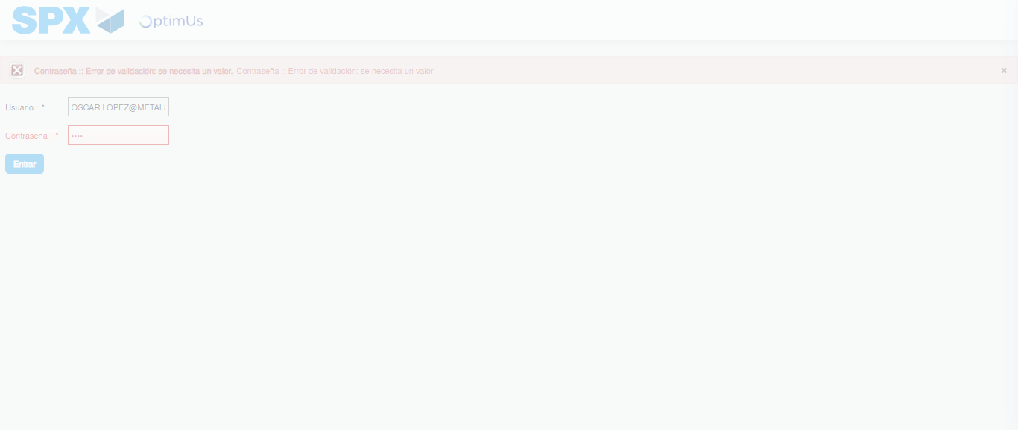Image file-name: QC_Testing-tc005_SPX_Dev5_Crear_Requisicion_Spot_Con_FAD_Tipo_Cobro_Project-1784573829435

Step 2 - Select to UEN and Access to Spot Buy Requisitions : UEN Correctly selected and Correct access
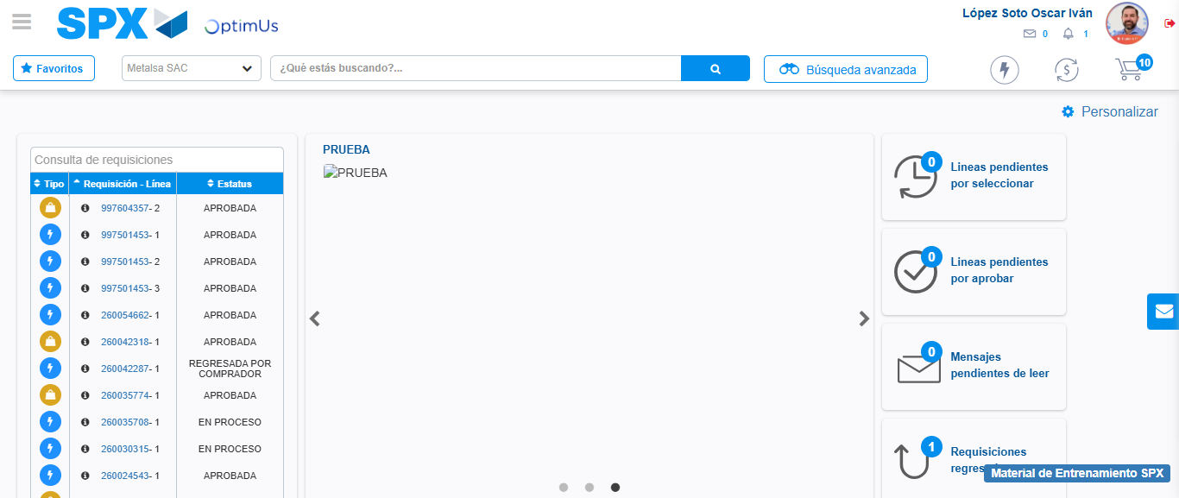Image file-name: QC_Testing-tc005_SPX_Dev5_Crear_Requisicion_Spot_Con_FAD_Tipo_Cobro_Project-1784573906091

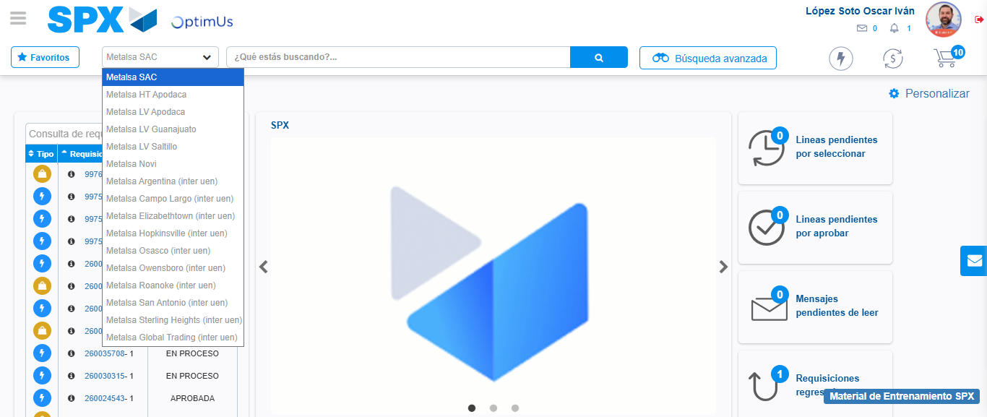Image file-name: QC_Testing-tc005_SPX_Dev5_Crear_Requisicion_Spot_Con_FAD_Tipo_Cobro_Project-1784573908937

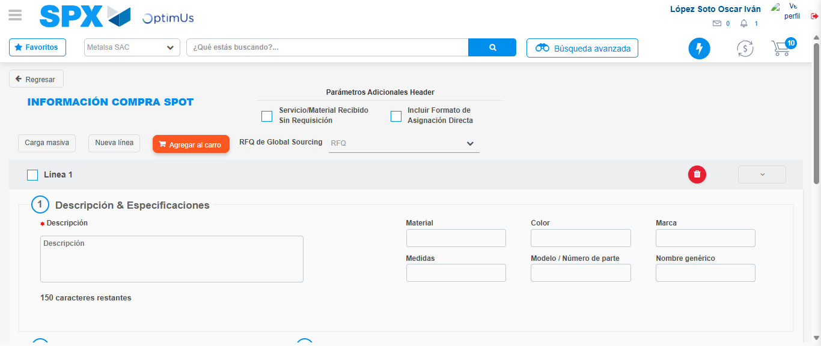Image file-name: QC_Testing-tc005_SPX_Dev5_Crear_Requisicion_Spot_Con_FAD_Tipo_Cobro_Project-1784573931926

Step 3 - Add FAD to Requisition: FAD Successfully Added
Image file-name: QC_Testing-tc005_SPX_Dev5_Crear_Requisicion_Spot_Con_FAD_Tipo_Cobro_Project-1784573932215

Image file-name: QC_Testing-tc005_SPX_Dev5_Crear_Requisicion_Spot_Con_FAD_Tipo_Cobro_Project-1784573932481

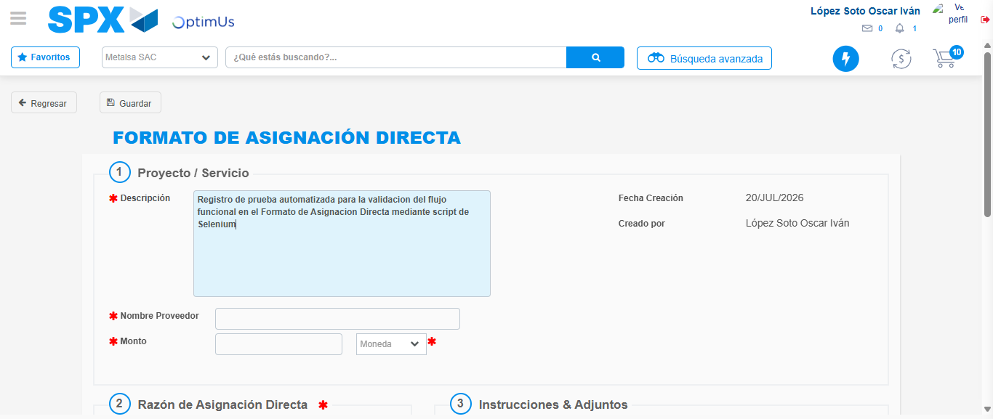Image file-name: QC_Testing-tc005_SPX_Dev5_Crear_Requisicion_Spot_Con_FAD_Tipo_Cobro_Project-1784573935546

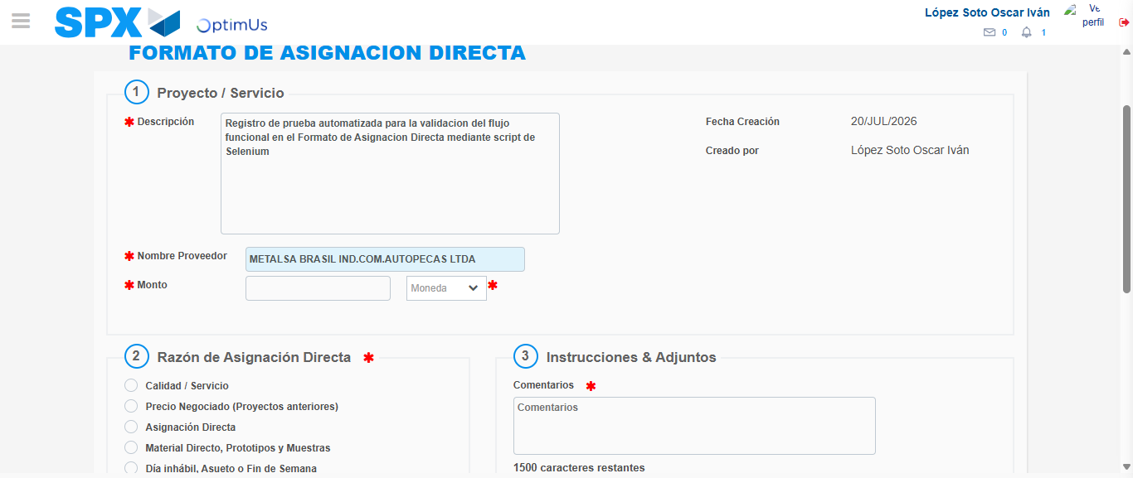Image file-name: QC_Testing-tc005_SPX_Dev5_Crear_Requisicion_Spot_Con_FAD_Tipo_Cobro_Project-1784573942875

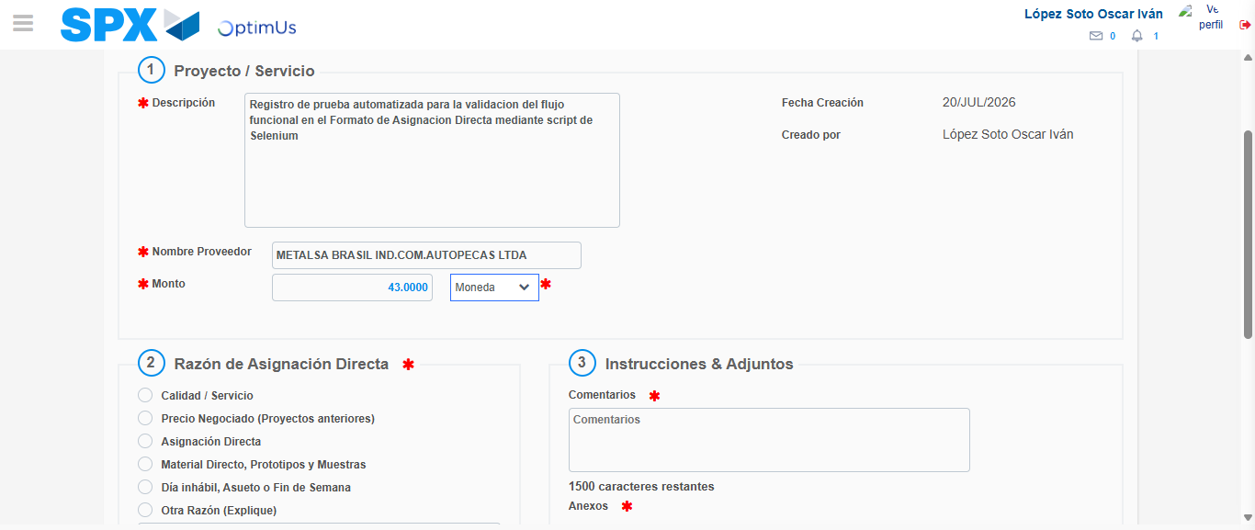Image file-name: QC_Testing-tc005_SPX_Dev5_Crear_Requisicion_Spot_Con_FAD_Tipo_Cobro_Project-1784573943314

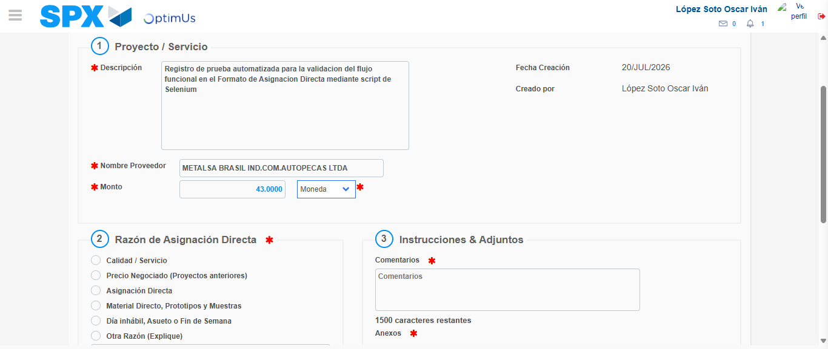Image file-name: QC_Testing-tc005_SPX_Dev5_Crear_Requisicion_Spot_Con_FAD_Tipo_Cobro_Project-1784573943594

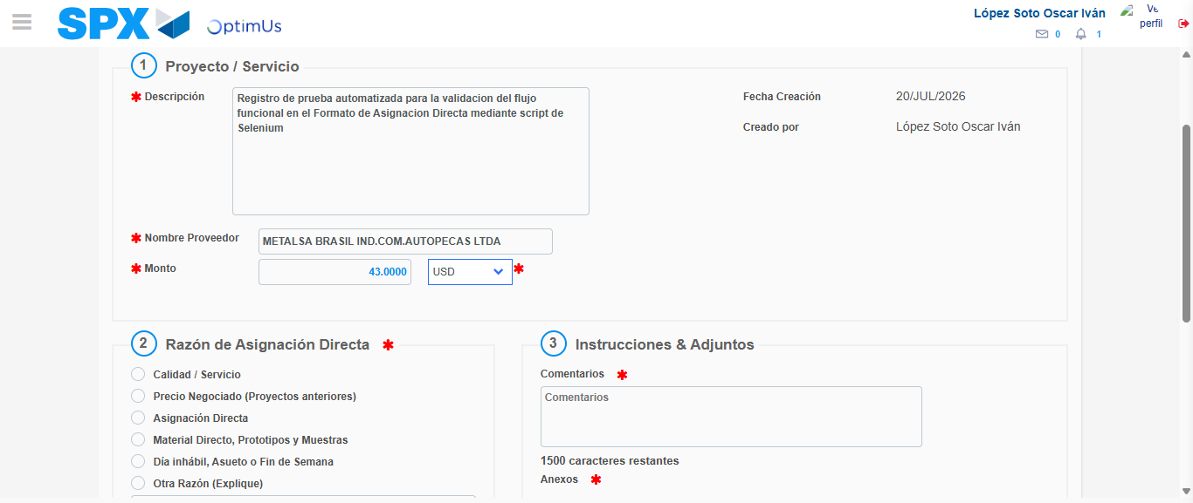Image file-name: QC_Testing-tc005_SPX_Dev5_Crear_Requisicion_Spot_Con_FAD_Tipo_Cobro_Project-1784573944143

Image file-name: QC_Testing-tc005_SPX_Dev5_Crear_Requisicion_Spot_Con_FAD_Tipo_Cobro_Project-1784573944355

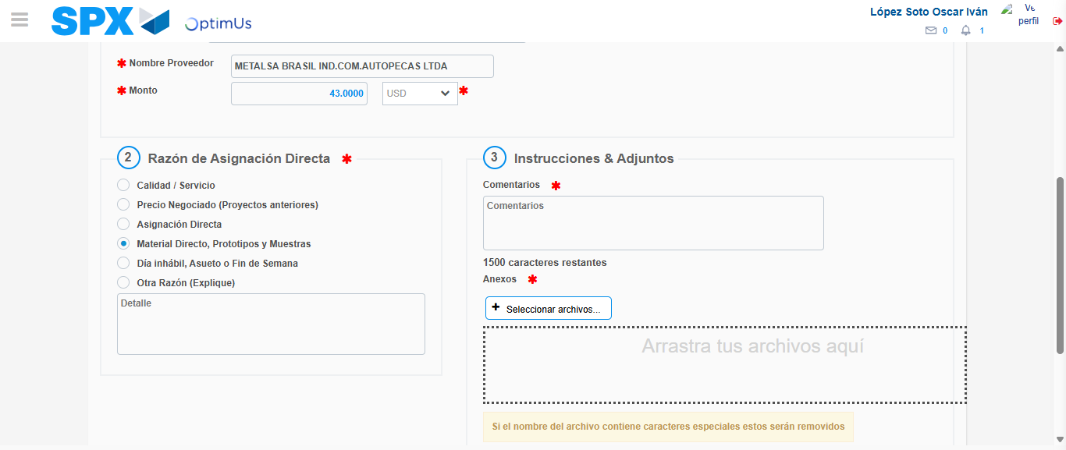Image file-name: QC_Testing-tc005_SPX_Dev5_Crear_Requisicion_Spot_Con_FAD_Tipo_Cobro_Project-1784573945356

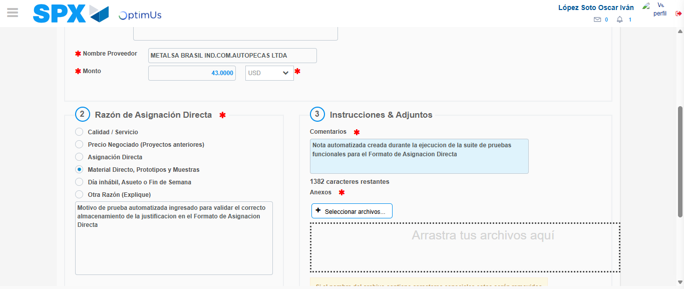Image file-name: QC_Testing-tc005_SPX_Dev5_Crear_Requisicion_Spot_Con_FAD_Tipo_Cobro_Project-1784573956719

Image file-name: QC_Testing-tc005_SPX_Dev5_Crear_Requisicion_Spot_Con_FAD_Tipo_Cobro_Project-1784573957630

Step 4 - Data Capture Spot Buy Requisition: Data captured correctly
Image file-name: QC_Testing-tc005_SPX_Dev5_Crear_Requisicion_Spot_Con_FAD_Tipo_Cobro_Project-1784573932215

Image file-name: QC_Testing-tc005_SPX_Dev5_Crear_Requisicion_Spot_Con_FAD_Tipo_Cobro_Project-1784573932481

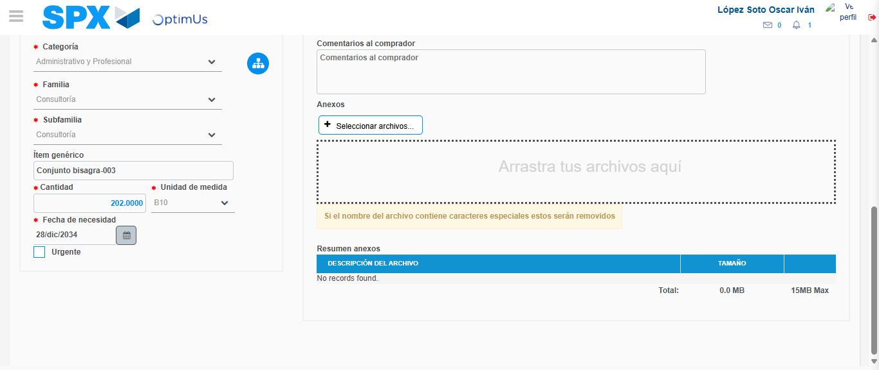Image file-name: QC_Testing-tc005_SPX_Dev5_Crear_Requisicion_Spot_Con_FAD_Tipo_Cobro_Project-1784573971520

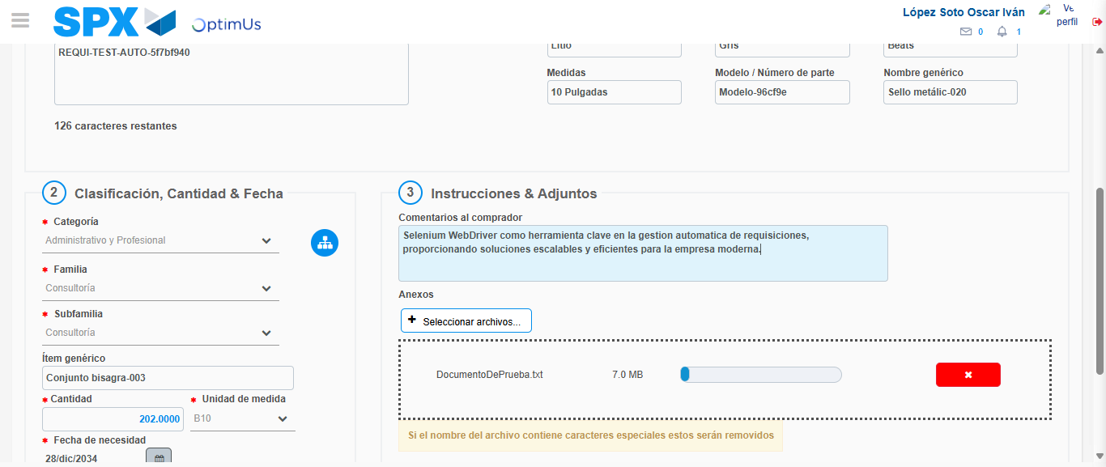Image file-name: QC_Testing-tc005_SPX_Dev5_Crear_Requisicion_Spot_Con_FAD_Tipo_Cobro_Project-1784573972425

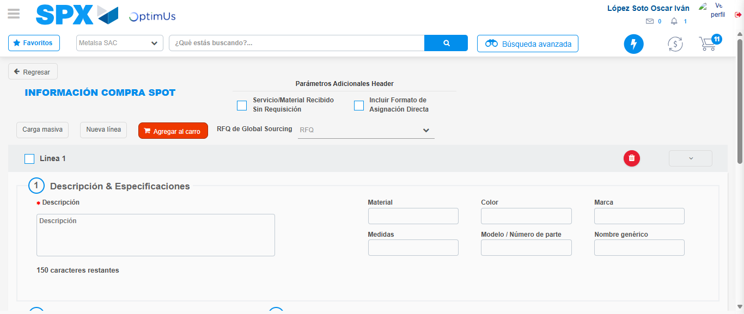Image file-name: QC_Testing-tc005_SPX_Dev5_Crear_Requisicion_Spot_Con_FAD_Tipo_Cobro_Project-1784573980194

Step 8 - Return to Main Page SPX : Return to Main Page SPX
Image file-name: QC_Testing-tc005_SPX_Dev5_Crear_Requisicion_Spot_Con_FAD_Tipo_Cobro_Project-1784573906091

Image file-name: QC_Testing-tc005_SPX_Dev5_Crear_Requisicion_Spot_Con_FAD_Tipo_Cobro_Project-1784573908937

Image file-name: QC_Testing-tc005_SPX_Dev5_Crear_Requisicion_Spot_Con_FAD_Tipo_Cobro_Project-1784573931926

Image file-name: QC_Testing-tc005_SPX_Dev5_Crear_Requisicion_Spot_Con_FAD_Tipo_Cobro_Project-1784573982515

Image file-name: QC_Testing-tc005_SPX_Dev5_Crear_Requisicion_Spot_Con_FAD_Tipo_Cobro_Project-1784573982769

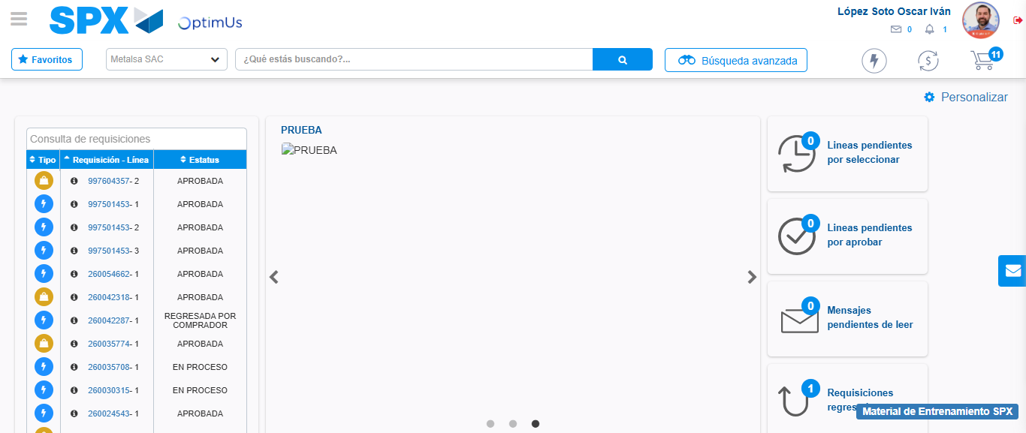Image file-name: QC_Testing-tc005_SPX_Dev5_Crear_Requisicion_Spot_Con_FAD_Tipo_Cobro_Project-1784574003949

Step 9 - Log Out : Log Out SPX
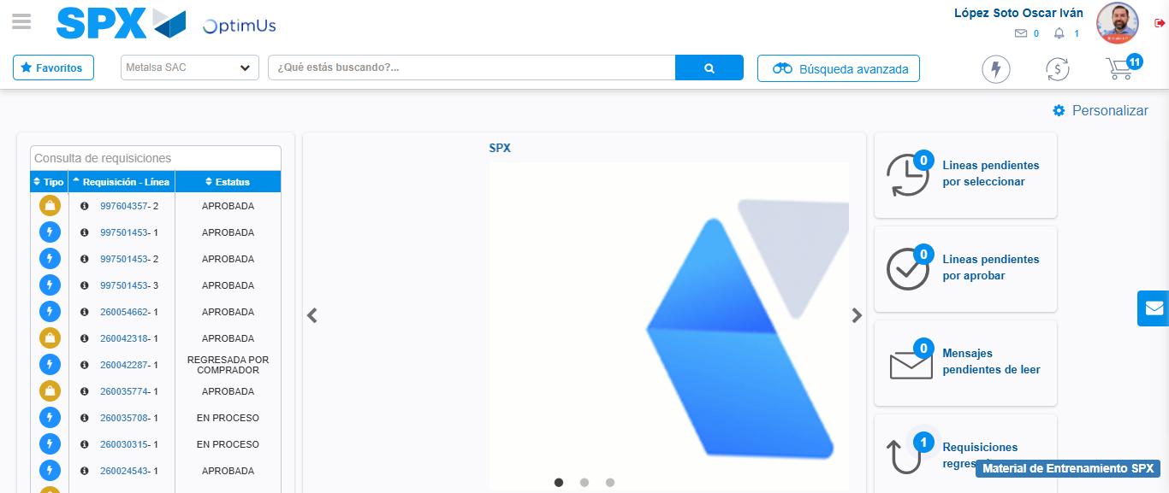Image file-name: QC_Testing-tc005_SPX_Dev5_Crear_Requisicion_Spot_Con_FAD_Tipo_Cobro_Project-1784574004397

